Report zu Übung 2

Gruppe 4
Rainer Bernhard, 0828592
Sifuentes Caccire Fausto Heraldo, 0607000
Gangl Andrea, 1025756

Assignment 4: Image Stitching
Für diese Aufgabe sollen Interest Points gefunden werden und anhand dieser dann ähnliche Bilder zusammengefügt werden. Dieses Problem gliedert sich in drei Unterpunkte. Zuerst müssen mittels SIFT Interest Points gefunden werden, danach müssen die gefundenen Punkte miteinander zugeordnet werden und zu guter Letzt wird dann das fertige Bild erstellt.

A. SIFT Interest Point Detection

Implementierung

Resultat
- Show the output of vl_plotframe on the chosen image. What is the meaning of the size
of the drawn circles and lines inside the circles?
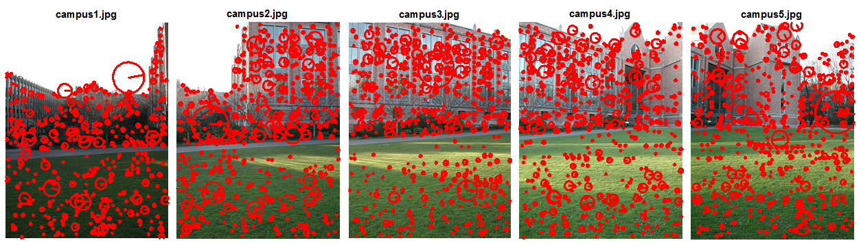

B. Interest Point Matching and Image Registration

Implementierung

Resultat
- Plot the matches after step 2. Describe in detail what vl_ubcmatch does.
- Plot the matches of the inliers after step 4. What is the difference to the set of all putative
matches we plotted before?
- Apart from small errors, the images should be aligned after step 5. Demonstrate that by
showing the absolute differences between the two images.
- Examine if the presented scheme of SIFT interest point detection and RANSAC-based
alignment is invariant to changes in image rotation and scale. Thus, likewise to assign-
ment 3, resize and rotate the second image and repeat the alignment procedure.

C. Image Stitching

Implementierung

Resultat
- Show and discuss the achieved results (with the two provided image sequences and your
own sequence). The result might look quite realistic at a ﬁrst glance but can you spot any
errors by looking on details?
- Compare a result achieved with feathering to a result where no blending has been per-
formed (i.e. the color values of only one image are taken for the stitched image). What is
the difference of the two results?

Assignment 5: Scene Recognition with Bag of Visual Words

Implementierung

Resultat
- In general, this approach should achieve a classiﬁcation rate of around 60%. Show and
discuss your results in the report. Show the confusion matrix and describe if there are
classes which can be more easily identiﬁed than others. Additionally, describe if there are
class pairs which are confused with one another more often than other pairs.
- Take some own test images and investigate if they can be correctly classiﬁed by your
simple scene recognizer. For instance, make a photo of your own kitchen or living room
and classify it. You should at least test one own photo from three of the eight categories.
Das Resultat unserer Klassifizierung wird in folgender Tabelle gezeigt.
Tabelle 1 Confusion Matrix
Klassen | Bedroom | Forest | Kitchen | Living Room | Mountain | Office | Store | Street
Bedroom | 25 | 0 | 13 | 30 | 1 | 14 | 8 | 9
Forest | 0 | 91 | 0 | 0 | 7 | 0 | 0 | 2
Kitchen | 6 | 0 | 49 | 17 | 0 | 17 | 10 | 1
Living Room | 10 | 0 | 21 | 36 | 0 | 11 | 17 | 5
Mountain | 3 | 4 | 0 | 1 | 73 | 1 | 7 | 11
Office | 4 | 0 | 14 | 9 | 0 | 73 | 0 | 0
Store | 7 | 3 | 7 | 19 | 0 | 4 | 50 | 10
Street | 3 | 0 | 3 | 5 | 1 | 1 | 25 | 62

Die Werte in der Diagonale sind die richtig klassifizierten Bilder. Es fällt dabei auf, dass die Klasse „Forest“ von allen Klassen am besten erkannt wurde. Es wurden Bilder aus dem Bereich „Forest“ dabei 4 Mal zur Klasse „Mountain“ und 3 Mal zur Klasse „Store“ klassifiziert.
Anzumerken ist auch, dass die Klassen „Bedroom“ und „Living Room“ oft miteinander verwechselt werden. So wurden Bilder der Klasse „Bedroom“ 10 Mal als „Living Room“ und Bilder der Klasse „Living Room“ 30 Mal als „Bedroom“ erkannt.
Tabelle 2 Confusion Matrix der eigenen Testbilder
Klassen | Bedroom | Forest | Kitchen | Living Room | Mountain | Office | Store | Street
Bedroom | 1 | 0 | 0 | 0 | 0 | 1 | 0 | 0
Forest | 0 | 7 | 0 | 0 | 0 | 0 | 0 | 1
Kitchen | 0 | 0 | 1 | 0 | 0 | 0 | 0 | 0
Living Room | 0 | 0 | 0 | 1 | 0 | 0 | 0 | 0

